|  |  |  |
| --- | --- | --- |
|  | **Awareness** |  |
| Dr. Sridevi S  *Assistant Professor*  *Presidency university, Yelahanka*,  Bengaluru, Karnataka, India soumya.pradeepgd@gmail.com | Mr.Gali Giridhareswar  *Department of CSE, SoE,*  *Presidency university, Yelahanka,*  Bengaluru, Karnataka, India galigeethu45@gmail.com | Mr.A.Prudhvi Reddy  *Department of CSE, SoE,*  *Presidency university, Yelahanka,*  Bengaluru, Karnataka, India prudhvireddyavula123@gmail.com |
| Mr. R.Rukmananda Reddy  *Department of CSE, SoE,*  *Presidency university, Yelahanka*,  Bengaluru, Karnataka, India rukumananda369@gmail.com |  | Mr.T L V S Akash  *Department of CSE, SoE,*  *Presidency university, Yelahanka,*  Bengaluru, Karnataka, India vishnusathvikr@gmail.com |

**AQUAMETER: A Unified Platform for Enhancing WaterFootprint**

***Abstract* -** The escalating global water crisis, characterized by increasing water scarcity, pollution, and groundwater depletion, necessitates innovative solutions to foster sustainable water consumption practices. This paper presents AQUAMETER, a novel web platform designed to enhance public awareness of water footprints, particularly concerning food products and daily activities. By leveraging digital technologies such as Artificial Intelligence (AI) through the Gemini model, big data analytics, and user-friendly web interfaces, AQUAMETER provides individuals with readily accessible information on the water embedded in their daily lives. The platform features functionalities for calculating water footprints via text and image input, a personalized dashboard for tracking direct water usage, comprehensive multilingual support, and a rich repository of educational resources. This integrated approach aims to overcome the limitations of existing tools by offering a seamless, engaging, and informative experience that empowers users to make more water-conscious decisions, thereby contributing to broader water conservation efforts and addressing the urgent challenges of global water sustainability. By providing a unified and readily accessible platform, AQUAMETER aims to empower individuals to better understand their water footprint, promote sustainable consumption practices, and contribute to the collective effort in addressing the growing global water crisis.

***Index Terms - Water Footprint, Artificial Intelligence, Consumer***

***Awareness, Sustainability, Web Platform, Water Conservation,image detection, personalized dashboard, multilingual support, environmental awareness.***

I. INTRODUCTION

The world stands at a critical juncture concerning its freshwater resources. Statistics paint a stark picture of a global water crisis affecting millions across the globe. Approximately 703 million people lack access to clean water, a basic necessity for life, while a staggering 2.2 billion individuals do not have access to safely managed drinking water services.[1] The situation is further exacerbated by inadequate sanitation, with 3.5 billion people lacking access to safely managed sanitation facilities.3 Projections indicate a worsening trend, with between two and three billion people experiencing water shortages for at least one month each year.[2] This scarcity is expected to intensify, potentially displacing around 700 million people by 2030.5 The consequences extend beyond mere inconvenience; a lack of access to safe water and sanitation contributes to approximately one million deaths annually due to related diseases.6 These figures from organizations like the World Health Organization (WHO) and UNICEF underscore the urgent need for effective interventions to promote responsible water use. The concept of a water footprint has emerged as a crucial tool for understanding the totality of freshwater consumption associated with the goods and services we use. It quantifies the volume of water needed to produce each item, shedding light on the hidden water demands of our lifestyles. The increasing scarcity of readily available water, driven by pollution and the depletion of groundwater reserves, further amplifies the significance of understanding and managing our water footprints. This increased water footprint at both community and personal levels directly impacts public health and the well-being of future generations. Preventing severe droughts in water-stressed regions hinges on the adoption of more careful and efficient water usage practices, a goal that can be achieved through the widespread availability of water footprint data. Groundwater, a vital source of freshwater, is facing alarming rates of depletion worldwide. Studies utilizing data from over 170,000 wells reveal that global groundwater reserves are dwindling at an accelerating pace, particularly since the year 2000.[3] Arid regions heavily reliant on groundwater for agriculture, such as California, the Mediterranean, and Iran, are experiencing especially rapid declines. This unsustainable extraction of groundwater can lead to severe long-term consequences, including land subsidence, reduced streamflow in rivers, and the intrusion of seawater into coastal aquifers, rendering the water unusable.10 The widespread issue of water pollution further increases the problem of water scarcity. Globally, an estimated three billion people are at health risk due to a lack of water data on the quality of their water sources. Furthermore, billions of people rely on drinking water sources contaminated with faeces, posing significant health risks. The impact of pollution extends to various forms, including the millions of tons of plastic waste entering our oceans, rivers, and seas annually.[5] Even seemingly invisible pollutants, such as nitrogen, are projected to exacerbate water scarcity in numerous river basins by 2050 [6]. This degradation of water quality further diminishes the availability of usable freshwater, intensifying the global water crisis. Recognizing the potential of technology to address these pressing challenges, the AQUAMETER project aims to develop a user-friendly web platform that provides readily accessible water footprint information. By harnessing the power of digital technologies like AI, big data analytics, and intuitive web interfaces, AQUAMETER seeks to empower individuals with the knowledge necessary to make more sustainable consumption choices. The core objective of this project is to create a unified platform featuring water footprint calculation for food products via text and image input, a personalized dashboard for tracking direct water usage, comprehensive multilingual support to ensure global accessibility, and a dedicated section offering valuable educational resources on water conservation.

# II. RESEARCH GAP OR EXISTING METHODS

The field of water footprint assessment has evolved significantly over the past two decades, establishing itself as a critical framework for understanding the intricate relationship between human activities and freshwater resources. The concept encompasses the blue water footprint, representing the consumption of surface and groundwater; the green water footprint, indicating the use of rainwater stored in the soil; and the grey water footprint, which measures the volume of freshwater required to assimilate pollutants.[4] Researchers have extensively applied WFA across diverse sectors, including agriculture, to evaluate the water demands of crop production and livestock farming; industry, to analyze water use in manufacturing processes; and overall consumption patterns, to determine the water embedded in various products and services. The integration of Life Cycle Assessment (LCA) with WFA has further enhanced the ability to comprehensively evaluate the environmental consequences of water consumption throughout the entire value chain of goods and services. Key review articles by Hoekstra et al. (2011), Mekonnen and Hoekstra (2011), and Ridoutt and Pfister (2010) provide comprehensive insights into the methodologies, applications, and evolving landscape of water footprint assessment [7][8]. The advent of digital technologies has ushered in a new era of possibilities for sustainable water management. A wide array of digital tools and platforms are now available, ranging from sophisticated smart water meters that provide real-time data on water consumption to powerful Geographic Information Systems (GIS) that enable spatial analysis of water resources and intelligent decision support systems that aid in optimizing water allocation strategies.[10] Mobile applications have also emerged as valuable tools for promoting water conservation by allowing users to track their water usage, access educational resources, and engage in water-saving challenges. The concept of digital twins, virtual representations of real-world water systems, is also gaining traction for its potential to enhance the efficiency and resilience of water infrastructure through advanced simulations and predictive analytics.[12] Recent research, such as the work by Balanzá et al. (2024), Yousuf et al. (2024), and Khan et al. (2023), highlights the growing evidence of the positive impact of these digital technologies on promoting sustainable water use and increasing public awareness. Artificial Intelligence (AI) and Machine Learning (ML) are increasingly being recognized as powerful catalysts for advancing environmental sustainability, with significant applications in water resource management.[9] AI and ML algorithms are being deployed for predictive analytics, enabling more accurate forecasting of water demand, optimizing the operation of water distribution systems, and facilitating the early detection of critical events such as leaks and equipment malfunctions. Furthermore, AI-powered tools are being developed for real-time water quality monitoring, enhancing the ability to identify and respond to contamination events more effectively. However, a growing body of research also underscores the significant energy and water consumption associated with training and deploying complex AI models, emphasizing the need for a balanced perspective on the overall environmental impact of these technologies. Creating effective digital platforms for environmental awareness necessitates a strong focus on user-centric design principles. Research suggests that platforms designed with the user's needs and preferences in mind are more likely to be adopted and lead to meaningful engagement. Gamification, the integration of game-like elements into non-game contexts, has emerged as a promising strategy for enhancing user motivation and promoting behavioral changes in areas such as water conservation. Providing personalized feedback to users based on their individual consumption patterns and utilizing intuitive data visualization techniques can also significantly contribute to increased awareness and more sustainable resource use. Studies by Zhao (2024), Norman (2013), and Johnson et al. (2016) offer valuable insights into designing user interfaces that are both usable and effective in conveying information and motivating desired actions, particularly in areas like water resources management, where digital technologies have a profound impact on optimizing systems, improving sustainability, and influencing user behavior. [9]. A review of existing water footprint calculators and environmental awareness platforms reveals certain limitations. While many tools offer basic water footprint calculations, few integrate features like image detection or detailed lifecycle analysis for food products. Furthermore, user engagement strategies often remain rudimentary, and multilingual support is frequently lacking, limiting global accessibility. For instance, while resources like the Water Footprint Calculator and the Water Footprint Network method provide valuable insights into water usage, they may not offer the seamless integration of features proposed by AQUAMETER. This analysis identifies several key research gaps: the absence of comprehensive platforms integrating calculation, image detection, personalized dashboards, and multilingual support; a limited focus on detailed lifecycle analysis for everyday food items; insufficient user engagement strategies; restricted accessibility for non-English speakers; and untapped potential in leveraging AI for user-friendly water footprint identification through image recognition.[11] AQUAMETER aims to address these gaps by providing a unique and integrated platform that combines these features to offer a more holistic and engaging user experience, ultimately contributing to greater water footprint awareness and the promotion of sustainable water consumption practices.

# III. PROPOSED METHODOLOGY

The proposed system aims to help users understand and track their water consumption through both text and image-based analysis of food items, along with personalized usage monitoring. Built using modern web technologies like ReactJS, Tailwind CSS, and Gemini AI, the platform offers a visually appealing, interactive, and multilingual experience. With features like detailed lifecycle analysis, image recognition, real-time water tracking, and educational content, AQUAMETER empowers users to make conscious decisions toward water conservation.

1. **Frontend Architecture and UI Technologies**

* + The frontend is developed using ReactJS for dynamic component rendering, Tailwind CSS for efficient styling, and Framer Motion for smooth animations, resulting in a fast and

responsive UI. Interactive

* + Reactions is used to add engaging interactive elements, making the user interface more intuitive and enjoyable.

1. **Gemini AI Integration for Core Functionality**

* + A fine-tuned Gemini model processes text inputs to provide accurate water usage data across a product's lifecycle stages like production, transport, and procurement.
  + Users can upload food images; Gemini’s image recognition identifies the item and fetches detailed water footprint data similarly to text input.

1. **Smart Search with Real-Time Suggestions** 
   * The search feature suggests results based on user input by comparing it against the model's training dataset, enhancing user convenience.
   * On selection, the frontend calls the Gemini API to fetch relevant data, ensuring a seamless, real-time experience.

1. **Image-Based Detection Module** 
   * Users can upload food item images; Gemini 2.5 Flash detects the object and fetches related water footprint data.
   * Helps users who may not know item names, making the feature accessible and user-friendly.

1. **Personalized Dashboard for Daily Usage Tracking** 
   * Users can log water usage across common tasks like bathing or gardening using an intuitive card-based layout.
   * The React-Chartjs library generates visual bar graphs showing consumption patterns, helping users track and optimize their water use.

1. **Multilingual Support for Global Accessibility** 
   * Google Translate API enables one-click translation of the entire site, including search results and dashboard, into multiple languages.
   * Language support ensures accessibility for users worldwide, regardless of linguistic background.

1. **Educational Resource Hub**

* + Offers articles, statistics, and tips on water conservation, helping users understand the significance of water footprints.
  + Educates users on types of water footprints (green, blue, grey), enabling more informed and sustainable lifestyle choices.

The AQUAMETER platform is a comprehensive,

AI-powered tool designed to raise awareness about water conservation by enabling users to track their personal water usage and understand the water footprint of various food items. Built with a modern frontend stack including ReactJS, TailwindCSS, Framer Motion, and Reactions, it delivers a smooth, responsive, and interactive user experience. The core intelligence of the platform is driven by a fine-tuned Gemini AI model that supports both natural language and image-based queries, allowing users to either type or upload food images to retrieve detailed lifecycle-based water footprint data. IndexedDB is used for session-based data storage, ensuring quick, private access to personalized usage insights.

The platform features a visual dashboard for daily water tracking, multilingual support via Google Translate, and an educational section with water-saving tips and footprint insights—empowering users to make informed, sustainable choices.

# IV. OBJECTIVES

The AQUAMETER research paper aims to develop a comprehensive, user-friendly digital platform dedicated to water footprint estimation and management by leveraging advanced technologies such as AI, big data, and blockchain. The primary objective is to empower users with accurate, real-time insights into water consumption across various life stages and products. The objectives are structured around the platform’s core functionalities, technological integration, user experience, and broader environmental impact. Below are the detailed research objectives presented in a structured format:

**Develop a Robust Water Footprint Calculation Module**

* **Precise Estimation:**

Design and implement an algorithm that calculates the water footprint of various consumable products, particularly food items. This involves quantifying the water required across all phases of a product’s lifecycle—from raw material sourcing through production, transportation, and final usage.

* **Data Integration:**

Integrate a curated database of water usage metrics, developed from over 600 data samples, ensuring that the calculations reflect real-world water consumption patterns and can be updated as new data becomes available.

**Integrate AI-Powered Image Recognition for Enhanced Accuracy**

* **Gemini AI Utilization:**

Employ a fine-tuned Gemini AI model, specifically modified for water usage prediction and image detection, to offer users an alternative and intuitive mode of interaction. The platform will allow users to upload images of food items or products to automatically fetch water footprint data.

* **Dual-Input Capabilities:**

Enable both text-based search and image-based identification to ensure that users can access water footprint information even when they are uncertain of a product’s name, enhancing usability and broadening accessibility.

**Design a Personalized Dashboard for User Engagement and Analysis**

* **User Data Visualization:**

Create an interactive, card-based dashboard where individuals can manually enter daily water consumption data for routine activities such as washing, gardening, and eating. This visual tool will use bar graphs and other chart formats to illustrate consumption trends over time, making complex data accessible.

* **Interactive and Real-Time Feedback:**

Integrate tools like React-ChartJS and asynchronous API calls to provide real-time feedback on individual water consumption. This approach helps users better understand their personal impact on water resources and identify key areas for water conservation.

**Incorporate Multilingual and Multi-Regional**

**Accessibility**

* **Google Translate API Integration:**

Integrate multilingual support via the Google Translate API to ensure that the platform is accessible to non-English speakers. This objective addresses the global nature of water resource challenges by removing language barriers and enabling users worldwide to benefit from the platform.

* **Localized Content Adaptation:**

Ensure that the interface, as well as educational resources and water footprint data, are adapted to multiple languages so that cultural and regional differences in water consumption can be accurately represented and addressed.

**Enhance User Engagement through Educational**

**Resources and Interactive Features**

* **Resource Section Development:**

Assemble an educational repository containing articles, water-saving tips, lifecycle phase explanations, and global statistical trends. This content will help users contextualize their water consumption habits and foster long-term sustainable behavior.

* **Gamification and Personalized Feedback:**

Investigate and integrate interactive elements such as gamification strategies and personalized recommendations, which aim to motivate users to reduce water wastage and adopt more sustainable practices.

This project aims to build an all-in-one web platform that helps users understand and reduce their water footprint. It combines a calculator that estimates water usage for food and products, AI-powered image detection to identify items and their water impact from photos, and a personalized dashboard for tracking daily water consumption with simple visuals. The platform supports multiple languages to reach a global audience and includes educational content to raise awareness about sustainable water use. Designed to be modular and scalable, the platform brings together these features in a clean, user-friendly interface to drive informed, eco-conscious decisions.

V. SYSTEM DESIGN AND IMPLEMENTATION

The AQUAMETER platform is built on a modular architecture that integrates state-of-the-art digital technologies to deliver accurate water footprint calculations and promote sustainable water use. This platform merges a responsive and dynamic frontend, powered by modern web frameworks, with a robust backend that leverages fine-tuned AI models for both text and image-based water footprint estimation. The design addresses challenges related to data accuracy, multilingual accessibility, user engagement, and scalability, ensuring that detailed water resource information is readily available to a global audience.

*System Overview*

AQUAMETER employs a variety of cutting-edge technologies to support its comprehensive features. The frontend is developed using ReactJS, TailwindCSS, Framer Motion, and Reactions, which together create an interactive and visually appealing user interface. This interface not only facilitates dynamic search and intuitive input methods but also provides a personalized dashboard for tracking daily water consumption. On the backend, the system integrates a fine-tuned Gemini AI model—trained on over 600 water usage samples across 5 epochs—to perform precise water footprint calculations and object detection via an image recognition module. The platform also incorporates IndexedDB for fast, browser-based storage of user-specific session data, and it leverages the Google Translate API to support real-time multilingual content conversion.

APIs connect the frontend with backend services, enabling asynchronous calls that fetch water footprint data in real time. This connection is essential for ensuring that both text-based and image-based searches return detailed lifecycle information, including water usage during creation, production, transportation, and procurement phases. As a result, AQUAMETER not only calculates the overall water footprint but also provides granular insights that empower users to understand which stages of a product’s lifecycle are most water-intensive.

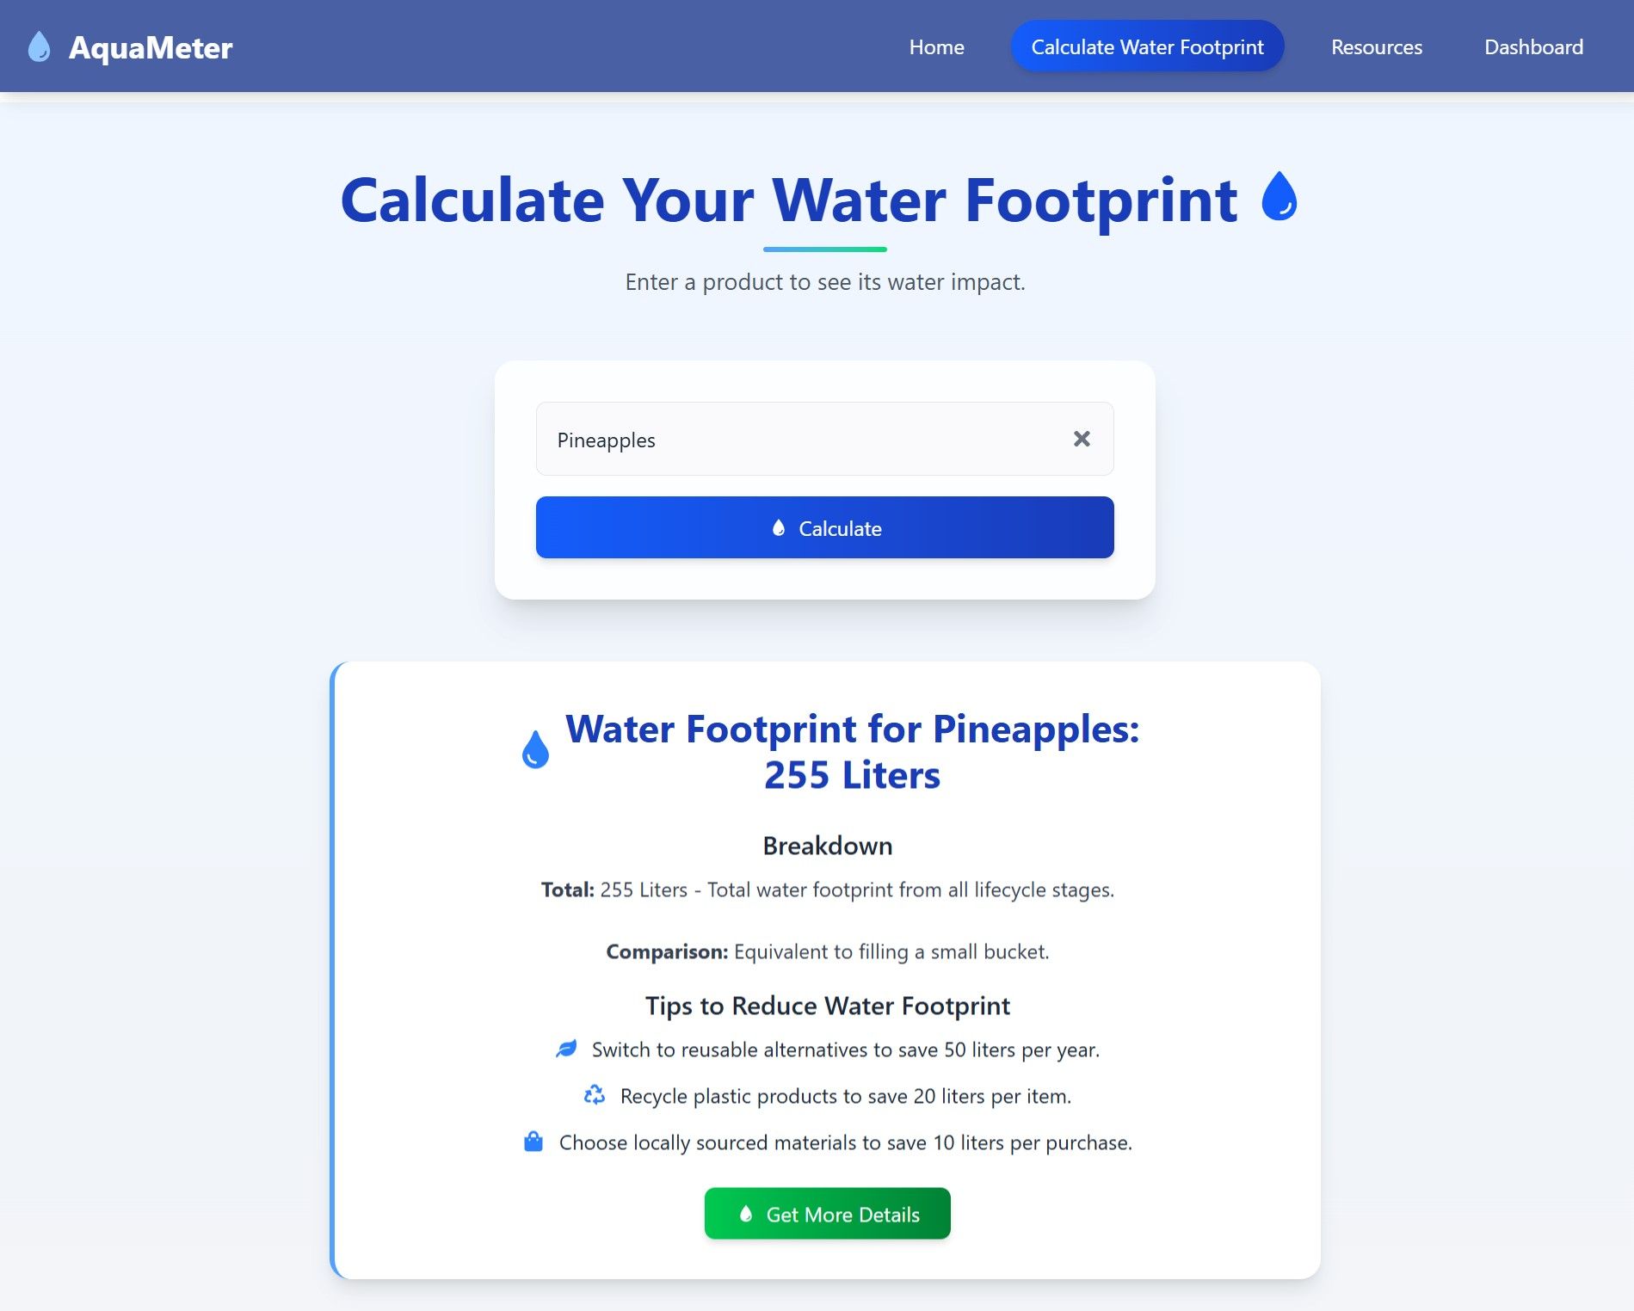

# Fig. 1 Website Overview

*System Architecture*

The platform is built using the following technologies and libraries:

* **Frontend:** 
  1. *ReactJS:* For building modular and interactive components.

○ *TailwindCSS:* To rapidly style the interface with a utility-first approach.

○ *Framer Motion & Reactions:* For enhancing user experience with smooth animations and dynamic interactive elements.

* **Backend:** 
  1. *Gemini AI:* A finely tuned AI model (integrated via API) is used for natural language processing and image detection, enabling precise water footprint calculations.

○ *IndexedDB:* Employed as a NoSQL

browser-based database for storing session data, ensuring quick access to personalized information.

* **APIs & Libraries:** 
  1. *Google Translate API:* Provides real-time multilingual support so users worldwide can view content in their preferred language.

○ *Asynchronous API Integration:* Connects the dynamic search bar with the Gemini AI model to fetch water footprint data based on user inputs.

○ *React-ChartJS:* Used to display water usage trends in interactive bar graphs on the personalized dashboard.

The frontend and backend are tightly integrated, ensuring a seamless user experience from initial query to detailed water footprint analysis. As shown in Fig. 1 (Website Overview), the architecture supports both text-based queries and image recognition inputs while securing data integrity with IndexedDB. The integration of multiple APIs ensures real-time responsiveness and supports future scalability and updates.

**Detailed Module Implementation**

1. **Water Footprint Calculation Module:**  AQUAMETER’s core functionality starts with a dynamic search bar that intelligently suggests product names by comparing user inputs against an extensive dataset. Once the user selects an item, an asynchronous API call is made to the fine-tuned Gemini AI model, which calculates the product’s water footprint and provides a detailed breakdown of its lifecycle phases.

1. **Image Detection Module:**

Recognizing that users might not always know the name of the product they wish to analyze, the platform incorporates an image recognition feature. Users can upload an image of a food item, and the Gemini 2.5 Flash model processes the image to identify the product and fetch its associated water footprint data in a manner analogous to the text search functionality.

1. **Personalized Dashboard:**

The dashboard presents a card-based UI where users can manually log water usage for various daily activities such as washing, gardening, or eating. With interactive increase/decrease buttons and real-time graphical visualizations using React-ChartJS, users can monitor their water consumption patterns and identify areas for conservation efforts.

1. **Multilingual Support Module:**  To ensure global accessibility, AQUAMETER integrates Google Translate API, enabling users to convert website content—including water footprint results, lifecycle phase details, and educational resources—into their preferred language instantly, all accessible from a conveniently placed navbar toggle.

1. **Educational Resources Section:**

Beyond calculation and tracking, the platform hosts a comprehensive resources section filled with educational content on water usage, conservation tips, and lifecycle analysis. This section utilizes internationally sourced data and statistics to empower users to better understand and manage water resources.

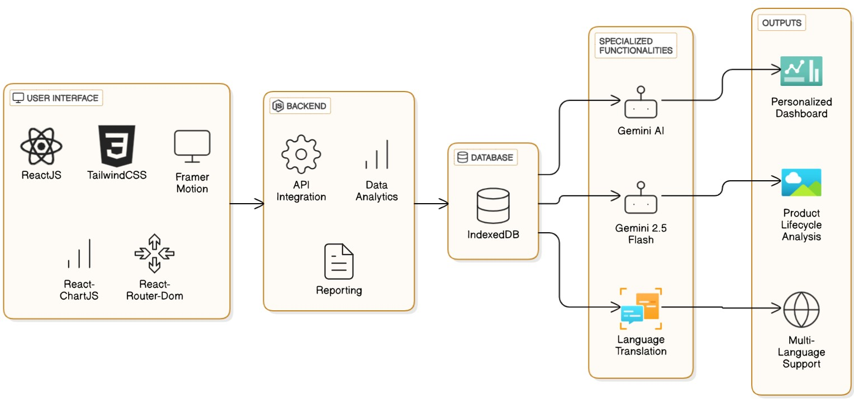

Fig. 2 System Architecture Overview

# VI. OUTCOMES

The implementation of AquaMeter has provided users with a transformative approach to understanding and managing their water footprints, fostering sustainable consumption habits. Users can now identify the water impact of their daily activities and access tailored educational content to improve water conservation practices, as supported by environmental awareness initiatives [2]. Based on their interactions, the personalized dashboard offers clear insights into water usage trends, empowering users to make informed decisions before engaging in high-water-impact activities, aligning with user-centered design principles [3].

Individuals found it highly beneficial to gain deeper insights into product water footprints through AI-driven lifecycle analysis, as seen in the detailed results provided after text or image inputs. They receive comprehensive data on water usage across production phases, building trust in the platform’s accuracy and reliability [11]. The system also highlights key water conservation concepts and statistics, providing a precise understanding of sustainable practices, as supported by educational integration in [4].

Implementing an interactive and intuitive methodology within AquaMeter has led to increased user engagement [14]. Features like image detection, real-time calculations, and the personalized dashboard with interactive charts have enhanced productivity and efficiency in delivering actionable water usage insights. The dynamic search bar and multi-language support ensure accessibility for a global audience, allowing users to explore water footprints in their preferred language and test their understanding through educational resources. This interactive design has proven effective in raising awareness, enabling users to clarify doubts by exploring detailed breakdowns or accessing conservation tips.

Table I. Comparison of Traditional Approach vs. Our Website Approach

|  |  |  |
| --- | --- | --- |
| **Aspect** | **Traditional**  **Approach** | **Aquameter** |
| Accessibility | Limited to manual research or expert consultation, often requiring technical knowledge. | Fully digital platform accessible from any device with internet access. |
| Information  Availability | Scattered across books, reports, or basic online tools, requiring significant effort. | Centralized repository with comprehensive water footprint data. |
| Application Process | Manual input and estimation, prone to errors and time-consuming. | Automated, AI-driven calculations ensuring accuracy and speed. |
| Engagement | Limited interaction, mostly static data presentation. | Interactive features like image detection and personalized dashboards. |
| Time Efficiency | Lengthy due to manual data gathering and calculation. | Instant results with real-time processing via APIs. |
| Resources | Separate from calculation tools, requiring additional effort to access. | Integrated resources for learning about water conservation. |
| Multi-language support | Rarely available, typically limited to one language. | Supports multiple languages via Google Translate API. |
| Data-Visualization | Basic or no visualization, hard to interpret. | Supports multiple languages via Google Translate API. |

AquaMeter integrates AI into water footprint calculation and user education, providing a superior experience compared to traditional methods [7]. This has empowered users with confidence in managing their water usage, ensuring they are well-equipped to contribute to water conservation efforts while maintaining accuracy and scalability, as emphasized by ethical and sustainable technology practices.

# VII. CONCLUSION

The AQUAMETER web platform represents a significant step towards enhancing public awareness of water footprints and promoting sustainable water consumption practices. By integrating user-friendly features such as text and image-based water footprint calculation, a personalized usage dashboard, multilingual support, and comprehensive educational resources, AQUAMETER offers a novel and comprehensive solution to address the growing global water crisis. The platform's innovative use of AI and modern web technologies provides an engaging and informative experience that empowers individuals to make more water-conscious decisions, ultimately contributing to a more sustainable future for our planet's precious freshwater resources.

**FUTURE SCOPE**

This AI-driven platform has the potential to expand its functionality and impact in the future, encompassing several key areas:

* **Personalized Recommendations**: Tailored water-saving tips based on user habits.
* **Broader Coverage**: Include textiles, electronics, and regional data.
* **Tech Integration**: Connect with IoT devices and enhance AI accuracy.
* **Community**: Offer interactive learning and user forums.

These methods can be applied to creating new opportunities to enhance engagement, accessibility, and sustainability globally.

**ACKNOWLEDGMENT**

The authors would like to acknowledge Presidency

University's support in providing resources and facilitating this research project. We are also grateful to the university librarians, professors, and research assistants for their assistance.

# REFERENCES

1. WHO and UNICEF, "Progress on Household Drinking Water, Sanitation and Hygiene: 2021 Update," World Health Organization, 2021, pp.

https://washdata.org.

1. UN-Water, "World Water Development Report 2020: Water and Climate Change," United Nations, 2020, pp. https://www.unwater.org/publications/world-water-development-report-2020/.

1. Famiglietti, J. S., "The Global Groundwater Crisis," Nature Climate Change, vol. 4, pp. 582–585, 2014, doi: 10.1038/nclimate2308.
2. Mekonnen, M. M. and Hoekstra, A. Y., "The green, blue and grey water footprint of crops and derived crop products," Hydrology and Earth

System Sciences, vol. 15, pp. 1577–1600, 2011, doi:

10.5194/hess-15-1577-2011.

1. Ridoutt, B. G. and Pfister, S., "Improving the water footprint of crops at a national scale: A case study for Australia," Water Resources and Economics, 2010, doi: 10.1016/j.wre.2010.05.001.
2. Jambeck, J. R. et al., "Plastic waste inputs from land into the ocean," Science, vol. 347, no. 6223, pp. 768–771, 2015, doi: 10.1126/science.1260352.
3. Hoekstra, A. Y. and Chapagain, A. K., "Water footprints of nations: Water use by people as a function of their consumption pattern," Water International, vol. 33, no. 2, pp. 230–239, 2008, doi:

10.1080/02508060801962090.

1. UNEP, "Single-Use Plastics: A Roadmap for Sustainability," United Nations Environment Programme, 2018, pp. – https://wedocs.unep.org.
2. Zhao, Xiaochun & Yang, Danjie & Zhou, Ying. (2024). The Impact of Digital Technology on Water Resources Management: Evidence from China. Water. 16. 2867. 10.3390/w16192867.
3. Jones, S. B. et al., "Smart Water Management: Integrating IoT with City Water Networks," Journal of Water Resources Planning and

Management, vol. 146, no. 4, 2020, doi:

10.1061/(ASCE)WR.1943-5452.0001151.

1. Krishnan, S.R.; Nallakaruppan, M.K.; Chengoden, R.; Koppu, S.; Iyapparaja, M.; Sadhasivam, J.; Sethuraman, S. Smart Water Resource

Management Using Artificial Intelligence—A Review. Sustainability 2022,

14, 13384. https://doi.org/10.3390/su142013384

1. Doe, Jane. "Digital Twins in the Water Sector: What Are They and

How Do We Get There?" DHIGroup Blog, April 1, 2024,

https://blog.dhigroup.com/digital-twins-in-the-water-sector-what-are-they-and -how-do-we-get-there/.